Name _________________________________ Date_________

The Perfect Packaging
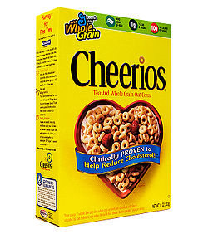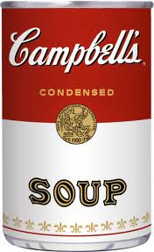
Every day we encounter products that are packaged in cardboard, aluminum or other material. They come in different shapes and sizes but did you ever wonder if they are the most cost efficient way to package the product? Could the company be saving money by optimizing their packaging to include the least amount of packaging material? Perhaps there is a way that they could make their packaging that would hold the same amount of product but would cost less to make. We are going to look into how today.
What you will need :
Two (2) regularly shaped products (cereal box, shoe box, soup can, etc.)
Centimeter ruler
String (If one product is a soup can)
Scissors
Construction paper
Tape

Goal
- Student will learn to determine optimum surface are and percent waste.
Objectives
- Work with a partner to determine the dimensions, volume and surface area of two containers
- Determine the minimum surface are of a shape given a constant volume.
- Compare and contrast optimized containers with actual containers.
- Determine precept waste in actual containers as compared to the optimum container.
Procedure
- Find two regularly shaped product containers and find their dimensions to the nearest half centimeter.
  - For boxes, measure the length, width and height of the box.
  - For cylinders, measure height and circumference with string. Use the circumference to determine the radius.
Container 1  Length (or Circumference):_______________  Width (or Radius):_______________  Height: _________________ | Container 2  Length (or Circumference):_______________  Width (or Radius):_______________  Height: _________________

- Determine the surface area and volume of both containers.
Box
$$V=lwh$$
$$SA=2\left(lw\right)+ 2\left(wh\right)+2\left(lh\right)$$

Cylinder
$$V=πr^{2}h$$
$SA=$2$πr^{2}+2πrh$

Container 1  Volume = ________________  Surface Area = _________________ | Container 1  Volume = ________________  Surface Area = _________________

- Find a formula for the height (in terms of the radius for cylinders or width for boxes) using the volume formula.
Reminder: You must find the measure of the length in terms of the width

Container 1: ________________________ | Container2:________________________

- Substitute this formula for the height in the surface area formula to find a new formula for the surface area and reduce.

Container 1: ________________________ | Container2:________________________

- Find the derivative of the formula.

Container 1: ________________________ | Container2:________________________

- Set the derivative equal to zero and solve for the width (or radius). Then find the remaining dimensions.

Container 1:  Width( or radius): _________________  Length( or circumference):________________  Height:_________________ | Container2:  Width( or radius): _________________  Length( or circumference):________________  Height:_________________

- Last, use your new dimensions to build an optimum surface area container.
Conclusion and Comparison Questions
- What is the minimum surface area for each container?

Container 1: ________________________ | Container2:________________________

- Compare the actual surface area with the minimum surface area.
  - What is the percent waste of each container?
$\% waste=\frac{Minimum SA – Actual SA}{Actual SA}$

  - Which products container is more cost efficient?
  - Which container seems more practical? What might keep a company from choosing the minimum surface area container?
- If each square cm of material costs $0.001, how much would a company save after making 1,000,000 products?

